# **EOSC 114 Fall 2024: Class Map 1 Part 1** *Student ID: 82673492*

**A Map of all the Natural Disasters Researched by Your Peers in Summer 2024**

INSTRUCTIONS:

1. **View and explore our Class Map** from this link:  
   <https://www.google.com/maps/d/u/0/edit?mid=1syGPG3cQnp-h44J_Jo0I_ACVU_qjuyY&usp=sharing>
2. **Review the questions on this Workseet** and find the answers in the Class Map.
3. **Complete this Worksheet** with your findings.
4. **Submit your data online (in Canvas)** by writing the [Class Map 1 Part 1: All the Natural Disasters Researched by Your Peers in Summer 2024](https://canvas.ubc.ca/courses/145537/quizzes/774893)

* Across Canada, which general type of disaster reported by class was spread out over the widest area (i.e. occurring over the farthest from East to West and North to South)? Do not consider the number of disasters reported; consider only coverage over the widest area.  
  *Note: Always check to ensure that markers are correctly placed. If they are wrongly placed, they don’t count as a hazard in that location.*
* Volcanoes
* Landslides
* Earthquakes
* Waves
* Storms
* Impacts
* What was the given latitude of an event identified to have occurred the closest to the North or South Pole?  
  *Notes:  
  Make sure the markers are correctly placed!  
  Use numbers only with 1 decimal point, e.g.: Whitehorse, Yukon Territory is at 60.7 latitude; the McMurdo Station, a US Research station in Antarctica is at -77.8 latitude.*

Most Northern: 71.7

Most Southern: -44.0

* Of all the general hazard types reported by our class, which “experience” category was reported the most?
* I Experienced It
* Family Member(s) Experienced It
* Friend/Acquaintance Experienced It
* Someone I Know Experienced It
* I Do Not Know Anyone who Experienced It
* Of the countries in the Central American Isthmus (Belize, Guatemala, El Salvador, Honduras, Nicaragua, Costa Rica, and Panama), which country was reported on the most with all types of disasters?  
  *Notes:  
  There may be more than 1 correct answer. Select ALL correct answers for full marks. There is a penalty for selecting an incorrect answer.  
  Always check to ensure that markers are correctly placed. If they are wrongly placed, they don’t count as a hazard in that location.*
* Belize
* Costa Rica
* El Salvador
* Guatemala
* Honduras
* Nicaragua
* Across North America, not including Mexico and the Caribbean, compare the majority of markers for earthquakes to those of landslides. How would you characterize the relationship between these two hazards in this region?
* The locations of these two hazards suggests they have causes that are related to each other.
* The locations of these two hazards suggests their causes have no relationship to each other.
* The locations of these two hazards suggests there is some relationship between their causes but not everywhere in this region.
* In which region of this map did you find the largest number of submissions?

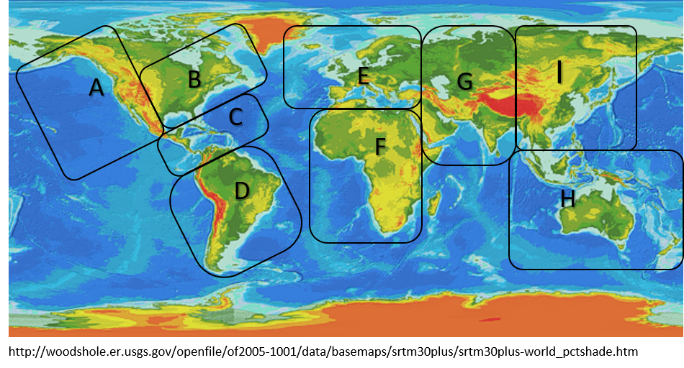

* A
* B
* C
* D
* E
* F
* G
* H
* I
* J = some other region not specified on this map
* Zoom the map so that you can see the entire of China. Which of the following landslide disasters were reported on the most?  
  *Notes:  
  There may be more than 1 correct answer. Select ALL correct answers for full marks. There is a penalty for selecting an incorrect answer.  
  Always check to ensure that markers are correctly placed. If they are wrongly placed, they don’t count as a disaster in that location.*
* Debris-flow or mud slide
* Rockfall
* Soil/earth landslide, slump or slip
* Some other type of landslide event
* A disaster event of any type studied was reported on which of the following world’s ocean(s)/sea(s)? The disaster must have occurred in an OCEAN/SEA, not ON LAND.  
  *Note: There may be more than 1 correct answer. Select ALL correct answers for full marks. There is a penalty for selecting an incorrect answer.*
* North Atlantic
* South Atlantic
* North Pacific
* South Pacific
* Arctic Ocean
* Southern Ocean
* Indian Ocean
* Mediterranean Sea
* Which of the following do you think is likely to be the most significant reason why, compared to other large countries, all of Russia has fewer natural disaster events identified on this map (other than the ones that are incorrectly placed)?
* There are no current volcanic areas in that country.
* There are no areas susceptible to landslides in that country.
* It is likely that no students in our current class were interested in natural disasters in that country.
* Impacts from space events in that country probably happen in uninhabited areas of the country.
* Natural disaster events in the country are most likely not reported.
* Across Australia and New Zealand, which general type of hazard were most commonly reported?  
  *Hint: Always check to ensure that markers are correctly placed. If they are wrongly placed, they don’t count as a hazard in that location.*
* Volcanoes
* Landslides
* Storms
* Earthquakes
* Waves
* Extinctions/Impacts
* Three of the reports on the Kilauea eruption on the island of Hawaii (or the “Big Island”) were not correctly placed on our map. What was(were) the mistake(s) in their placement?
* All had the wrong sign and/or magnitude for the latitude
* All had the wrong sign and/or magnitude for the longitude
* All had the wrong sign and/or magnitude for both the latitude and longitude
* The pins were placed on the wrong island
* Several reports of volcano-related disasters in the Mediterranean region were submitted. Which of the following volcano types is the most common among those reported?  
  *Hint: Always check to ensure that markers are correctly placed. If they are wrongly placed, they don’t count as a hazard in that location.*
* Stratovolcano
* Caldera
* Shield volcano
* Cinder cone
* Dome
* Across the archipelagic countries of Indonesia and the Philippines, compare the majority of markers for volcano- to those of wave-related events. How would you characterize the relationship between these two hazards in this region?
* The locations of these two hazards suggests they have causes that are related to each other.
* The locations of these two hazards suggests their causes have no relationship to each other.
* The locations of these two hazards suggests there is some relationship between their causes but not everywhere in this region.
* Across Canada, which TWO general types of disasters were most commonly reported?  
  *Hint: Always check to ensure that markers are correctly placed. If they are wrongly placed, they don’t count as a hazard in that location.*
* Volcanoes and Landslides
* Landslides and Extinctions/Impacts
* Storms and Waves
* Earthquakes and Extinctions/Impacts
* Waves and Earthquake
* Storms and Volcanoes
* After exploring the global map produced by your peers from Summer 2024, what did you find to be most interesting, intriguing or unexpected about it?

The fact that a lot of disasters happen in the west coast area of americas

* After exploring the global map produced by your peers from Summer 2024, name one map submission that grabbed your attention. What was most interesting about this natural disaster?

1964 Alaskan Earthquake, the sheer magnitude and destruction caused is stagerring